A Project On

# PHARMA+

Submitted in partial fulfilment of the requirement for the award of the degree of

**BACHELOR OF COMPUTER APPLICATIONS**

Of

## Bangalore University

By

Aditya N 20IKSB7001

**UNDER THE GUIDANCE OF**

**Ms. BHAVYA S**

**Coordinator,**

**Department of Computer Applications**



**2022-2023**

## SURANA COLLEGE

#167, 5th Main Road, Industrial Suburb, 2nd Stage,

Behind FTI, ESI Hospital, Peenya, Bangalore-22

### **SURANA COLLEGE**

#167, 5th Main Road, Industrial Suburb, 2nd Stage, Behind FTI, ESI Hospital, Peenya, Bangalore-22

#### Department of Computer Applications



### CERTIFICATE

Certified that the project work entitled **PHARMA+** carried out by **ADITYA N [20IKSB7001]**, bonafide student of this institute, in partial fulfilment of the event for the award of **Bachelor of Computer Applications** of **Bangalore University** during the academic year **2022-2023**. It is certified that all corrections/suggestions indicated for Internal Assessment have been incorporated in the report deposited in the department library. The project report has been approved as it satisfies the academic requirement in respect of Project work prescribed

for the said degree.

**Signature of the Guide**

**Ms. Bhavya S**

**Name of the Examiners**

**……………………………**

**……………………………**

**Signature of the HOD Signature of the Principal**

**Ms. Bhavya S Dr. Ramya R**

**Signature with date**

**……………………………**

**……………………………**

#### SURANA COLLEGE

#167, 5th Main Road, Industrial Suburb, 2nd Stage, Behind FTI, ESI Hospital, Peenya, Bangalore-22

**BACHELOR OF COMPUTER APPLICATIONS**

#### DECLARATION

I **ADITYA N [20IKSB7001]** a bonafide student of Surana College, hereby declare that the project entitled **PHARMA+ (E-Commerce Web Application)** submitted in partial fulfilment for the award of Bachelor of Computer Applications of the Bangalore University during the year 2022-2023 is our original work and the project has not formed the basis for the award of any other degree, fellowship or any other similar titles.

Name (Reg Nos.) Signature of the Student with date

**1) ADITYA N [20IKSB7001]** _____________________________

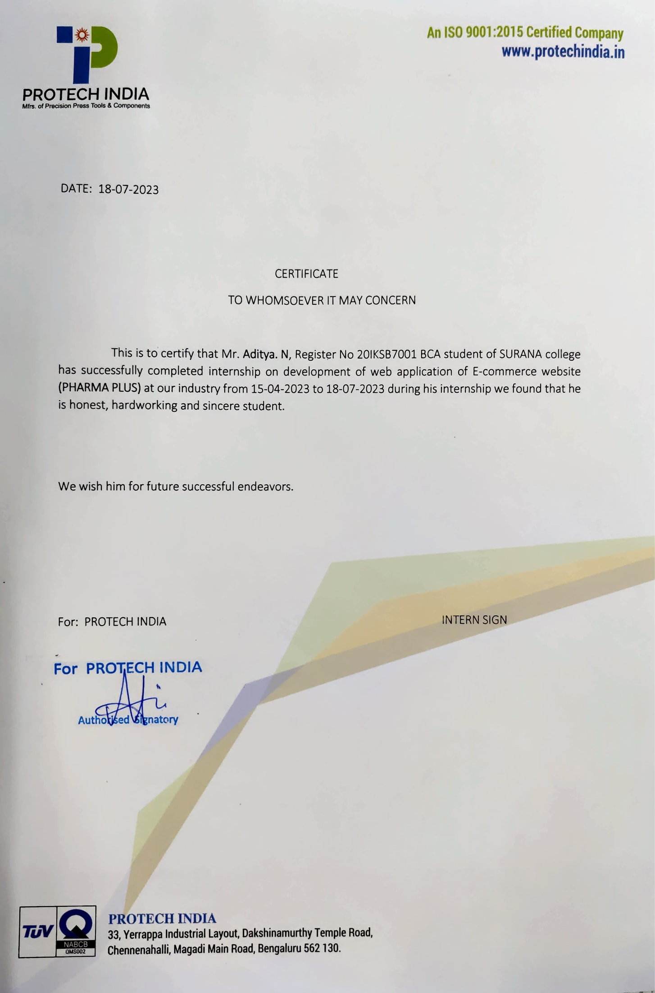

**ABOUT COMPANY**

PROTECH INDIA is amongst the leading Manufacturers of Precision Press Tools & Components. We are a 'Full-Service Supplier' from a concept through the supply of the Quality Product. The major goal of our team is to provide Quality Products with cost competitiveness. Our facilities have been certified to comply with Quality Management Systems standard as per ISO 9001: 2015.

#### Over the years

**2006** Commenced operations with 1CNC Wire cut Machine

**2007** Started to develop Press Tools and all types of Prototype Components of Press Components, Sheet metal cabinets, Enclosures and Name plates

**2008-10** Started to develop Proto Type of sheet metal components, Outsourcing of sheet metal components and Cabinets.

**2011** Installed Multi slide machinery to produce Precision Press Components at high speed in punching and forming combination process.

**2012**Streamlined operations in terms of Consistent quality and stringent delivery schedules

**2013** Invested on facilities for Press Shop & Tool Room.

**2014** Invested on SEMI MULTI SLIDE FORMING MACHINES .

**2015** Re-located to our new premises

**2016** Embarking on further expansion

#### Vision

* PTI is committed to embrace newer technologies, products & services.
* PTI will be responsive to customer requirements consonant with its core competence and profitability.
* PTI is committed to achieving a self-reviewing organization in perpetuity by adopting QMS as a way of life.

##### ACKNOWLEDGEMENT

I take this opportunity to express our sincere gratitude to all those who have assisted me in the project. I extend our heartfelt gratitude to the almighty for giving us the strength and mental support in proceeding with this dissertation.

First, I am grateful to our beloved Principal Dr. Ramya R and the Management of SEI for providing a congenial atmosphere and the necessary facilities for achieving the cherished goal.

I feel delighted to express our sincere thanks and deep appreciation to our guide and project coordinator Ms. Bhavya S, Coordinator, Department of Computer Applications, for her valuable guidance, keen interest, and constant encouragement throughout the completion of the project.

Finally, I am thankful to all our teaching staff and non-teaching staff for allowing me to carry out project work. I also thank my parents for their unconditional support.

##### ABSTRACT

**Project Title**: Pharma+

**Description:** The project mainly has two modules Admin and Customer. In **Pharma+,** Customer can view product without Creating any account. Suppose if he wants to purchase anything that is, if he clicks on add to cart it, will ask him to login first. To login he must create an account. By entering details Such as, name, mobile number, e-mail address, password, address. Once signed up, he Can The login using e-mail id and password. The email & password will be validated in the backend and authorize Customer to use. Admin can access dashboard after logging in and perform operations such as adding the product,

updating the product & deleting the product. In product it will have name, category, brand, price, image, quantity. Admin can view all the registered customers and also the session is validated i.e., admin should compulsorily login to use features/dashboard.

**Modules:**

* Admin Module
* Customer Module

**Requirements:**

**Hardware & Software**

**Hardware:**

* Processor: INTEL CORE i3
* Hard Disk: 500 GB
* Ram: 4.0GB

**Software:**

* Frontend: HTML&CSS, JAVASCRIPT, BOOTSTRAP
* Backend: JAVA, MySQL, Spring, Spring Boot